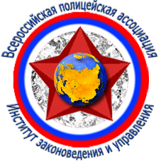
INSTITUTE OF JURISPRUDENCE AND MANAGEMENT
OF ALL-RUSSIAN POLICE ASSOCIATION

300039, Russia, Tula, St. Surikov, 2
Теl./fаx: (4872) 32-43-52, 24-27-21
E-mail: box@ izuvpa.ru
www.izuvpa.ru

17 февраля 2014 г. № 38

на № _____ от ___________________

Rector University of Nis
Prof. Dr. Dragan Antic

Dear Prof. Antic!

I inform you, that the student of your university Pavle Randjelovic (Faculty of Electronic Engineering, second year of study) has won first place in the international correspondence photocompetition "The beautiful - through the eyes of young generation" which organised our institute. The diploma of the winner and memorable gift are directed on a home address Pavle Randjelovic.
I hope, that cooperation between University of Nish and Institute of jurisprudence and management of the All-Russia police association will develop.

Sincerely yours,

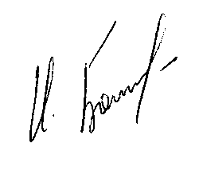
Rector of the Institute of jurisprudence and management
of all-Russian police Association
Doctor of Law, professor I.B. Bogoroditskii

