KNB Scholarship
Application Guidance



Directorate Institutional Affairs and Collaboration
Directorate General of Higher Education
Ministry of Research, Technology, and Higher Education
Republic of Indonesia
2015

- Forewords

Since we launched the KNB Scholarshipin 2007 as our primary international scholarship program to contribute more in the human resources development in our neighboring developing countries, we have been admitting more than 640 students coming from 64 developing countries around the world to get the scholarship and obtain their master degree in our prominent universities. They have been studying and earning their degree while experiencing the culture and traditions in the most diverse nation in the world.
We know thatmost of future applicants might be thinking: is spending 3 years in Indonesia to obtain their master degree worth it? And the answer is a resounding yes, getting the KNB scholarship and going to a master degree programin Indonesia is strategically worth it. Theirmaster degree will be one of the most lucrative investments they will make and that KNB scholarship can be vital to their post-college successThe program is very important not only to advance their knowledge and develop their competencies but also in certain degrees will strengthen the relationship between Indonesia and its neighboring developing countries by helping them nurturing their future leader.
Considering the recent development and potentials, we have tried to simplify and make better the KNB scholarship guidance to give the potential applicants as much information as possible on how to apply for the scholarship, and also highlight the best ways to boost their chances of receiving this scholarship.We do hope that this scholarship guidancewill adequately assist the potential applicantsto apply for the scholarship and to understand and comply with the scholarshiprules and regulations.

Thank you,

HermawanKresnoDipojono
Director of Institutional and Collaboration Affairs

- Brief Introduction to KNB Scholarship Program

The Tenth Conference of Heads of States of Non-Aligned Movement (NAM) countries commenced in Bandung from 1st – 6th September 1992 concluded, among others, the idea of scholarships provided by the Ministry of Education and Culture of the Republic of Indonesia for the student coming from the NAM member countries. Following that mandate, in 1993 the Government of the Republic of Indonesia started offering postgraduate (master degree) scholarships to students from the NAM member countries.
Since 2002, due to the substantial change in the international political constellation, the use of the term “NAM” in this program was considered irrelevant. The program name then changed to Kemitraan Negara Berkembang(Developing Countries Partnership)Scholarshipor KNB Scholarship.Consequently, the program have been widely offered to students, not only to the NAM member countries, but also to other developing countries such as Thailand, Fiji, Gambia, Senegal, Nigeria, Madagascar, Suriname, Pakistan, Guyana, Myanmar, Laos, Vietnam, and Vanuatu. In fact, this program has attracted more applicants as by 2013, 647 students from 64 countries had been awarded this scholarship.

- Program Objectives

- To contribute in the human resource development in the developing countries;
- To promote deeper cultural understanding between developing countries;
- To strengthen the relationship and cooperation between developing countries.

- Study Programs Offered

The scholarship is offered to potential student from developing countries to earn their Master Degree in one of 13 prominent universities in Indonesia. The study programsoffered by those universities are listed below (please be advised that the study program offered is differs betweenuniversity):

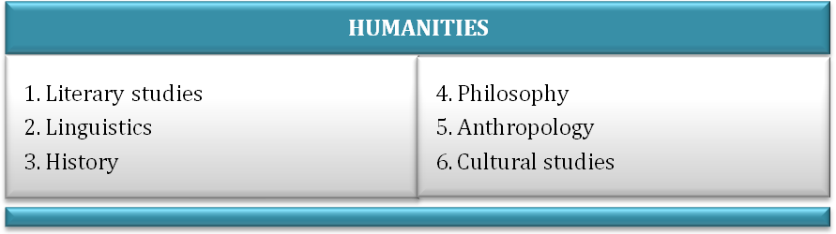

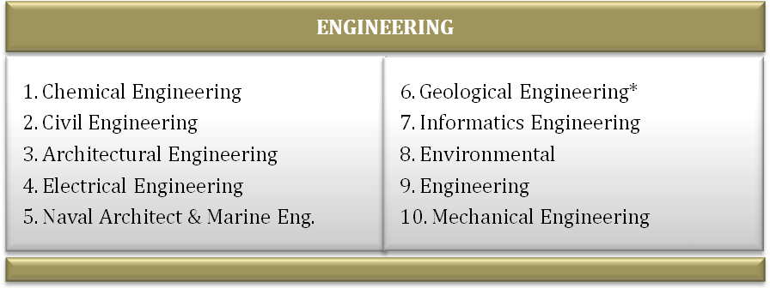

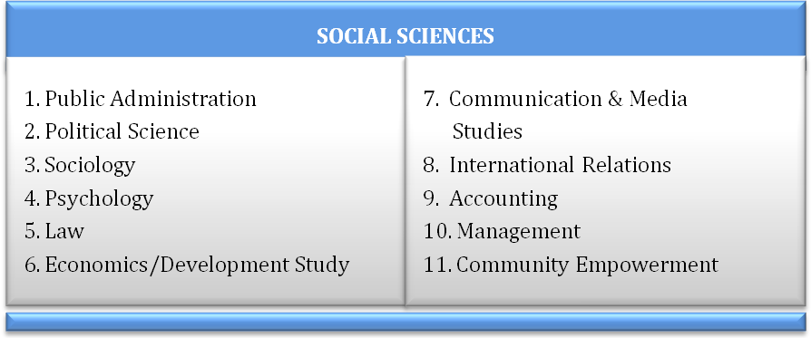



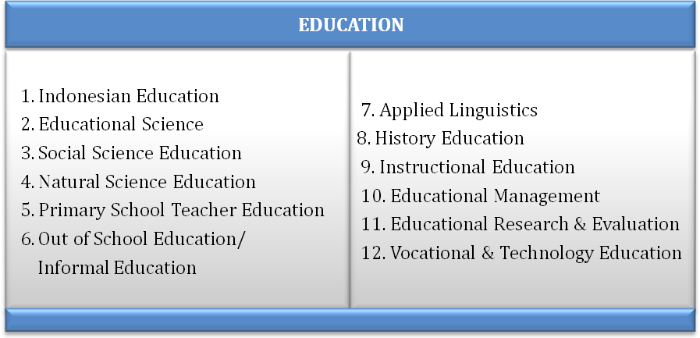

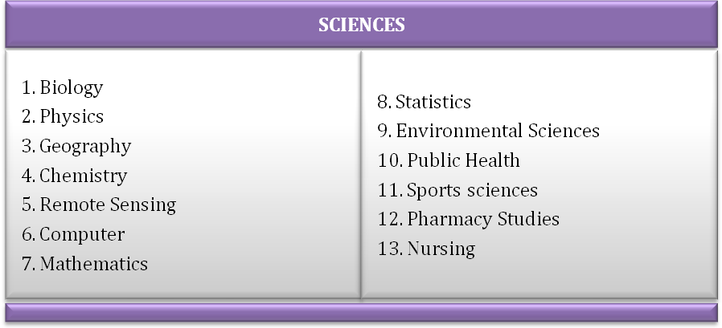

- Period of Study

No | Programs | Period of Study
1 | Indonesian Language Preparation | 8 months
2 | Master Preparatory Programs | 4 months
3 | Master Programs | 24 months (4 semester)

- Learning Process

- Language
Language instruction in lectures is recommended in Bahasa Indonesia
- Thesis
Thesis should be written in Bahasa Indonesia unless the university suggested otherwise
- Research
Research should be carried out in Indonesia

- Scholarship Coverage

The KNB Scholarship covers:
    - A Settlement Allowance of IDR 1,000,000 will be given to new students upon their arrival in Indonesia;
    - While taking the Indonesian language course and preparatory programs, the new students will only receive a Living Allowance of IDR2,350,000 per month;
    - During the Master Program, the KNB students will receive a scheme of monthly allowance as detailed below:
No | Allowances | Amount
1 | Living Allowance | IDR 2,350,000
2 | Research Allowance | IDR 400,000
3 | Books Allowance | IDR 350,000

    - A health insurance with a maximum of IDR 200,000 monthly premium (In case of the cost of medical services exceeded to those covered by the health insurance, the difference should be borne by the student);
    - A round-trip international airfare (economy class) from the international airport of the student’s home countries to Indonesia, including local transport to the host university;
    - The scholarship will be provided for a maximum of 36 months (In case of early program completion, the scholarship will be stopped soon after the student set off for their home country);
    - Please be advised that the scholarship scheme will only sufficient to cover one person to living properly in most cities where the universities are located.
* Note: Other expenses beside above mentioned items will be considered as personal expenses and will be borne by the students.

- Requirements

      - Maximum age is 35 years old;
      - Posses a bachelor degree (master degree holder is not eligible to apply);
      - Have a TOEFL score of 500 or equivalent;
      - Complete the on-line application form;
      - Prior to the departure to Indonesia, the successful candidates will have to sign a statement letter provided by the KNB Scholarship management.

- How to Apply

- Required Documents
- Recommendation letter from the Indonesian Embassy in the respective country;
- Nomination letter from the respective government official;
- 2 Academic Recommendation letters;
- Scanned passport (personal data page only) or birth certificate;
- Scanned bachelor certificate and academic transcripts (in English);
- Scanned TOEFL score certificate obtained within the last 2 Years;
- Scanned Medical Statement.

- Application Procedures
  - Download the Invitation Letter posted in the KNB Scholarship website;
  - Submit the Invitation letter, Passport or Birth Certificate, Academic Certificates and Academic Transcripts to the Indonesian Embassy to acquire the recommendation letter;
  - Complete the online application process;
  - Selection process;
  - The Selection Results will be broadcastedonline in the KNB Scholarship Website and officially announced through the Indonesian Embassy publication network;

Please be advised that all application process is conducted online through KNB Scholarship website www.knb.dikti.go.id.

During the application process, please pay close attention to some important information below:
      - We strongly suggest you to collect as many information as possible on the universities and your desired study program. Please be advised that once you are admitted, changing either the universities or your study program is strictly prohibited.
      - The recommendation letter from Indonesian Embassy is a mandatory. The recommendation letter will be issued based on verification and necessary background and/or security checksconducted by the Indonesian Embassy. In case of no Indonesian official representative in your country, you need to obtain the letter from any Indonesian Embassy accredited to your country.
      - All the required documents have to be written or officially translated in English.
      - The participants from English speaking country are not necessarily excluded from the requirement to attach the written prove of their English proficiency.
      - The universitieshave all rights to conductthe selection methods including online interviewwith the potential candidates.

- Schedule
- The online application process must be completed no later thanApril15th2015;
- Selection process will be conducted onthe 1stweek of May;
- The selection result will be announce onthe 1stweek ofJune ;
- The students are expected to arrive in Jakarta bythe endofAugust;
- Orientation will be organized in September;
- The Indonesian language course will commence in earlySeptember.

- Contact

- Directorate General of Higher Education
Ministry of Research, Technology and Higher Education
Republic of Indonesia
D Building, 6th Floor
JalanJenderalSudirman, Senayan, Jakarta 10270
Phone : +6221 57946063
Fax : +6221 57946062
Email : knb.scholarship@gmail.com
- Director of Public Diplomacy
Ministry of Foreign Affairs
Republic of Indonesia
Jalan Taman Pejambon No. 6, Jakarta
Phone : +6221 3813480
Fax : +6221 3858035

List of Universities

No | University | City | Address, Phone, Website, Email | Contact Person
1. | Bogor Agricultural University (IPB) | Bogor | Graduate School  Andi Hakim Nasution Building, 5th Floor  Kampus IPB Darmaga, Bogor  Ph.:+622518628448  Fax.:+622518622986  Email:sps@ipb.ac.id  Website: www.pasca.ipb.ac.id | SholehHidayat  +6285775001310  Sarah Marini  +62818104797
2. | Bandung Institute of Technology (ITB) | Bandung | International Office  Jl. Ganesha No. 17  Ph. & Fax.: +62222504282  Email: tdirgantara@pusat.itb.ac.id  Website: www.itb.ac.id | Tatacipta Dirgantara  +628122031655
3. | SepuluhNopember Institute of Technology (ITS) | Surabaya | International Office ITS  Gedung Rektorat Lt. 2, Kampus ITSKeputih-Sukolilo, Surabaya 60111  Ph.: +62315994251ext. 1224  Fax: +62315923411  Email: int_off@its.ac.id  Website: www.its.ac.id | HeriKuswanto  +62818513223
4. | GadjahMada University (UGM) | Yogyakarta | International Office  Gedung Pusat UGM Lt.2  Bulak Sumur Yogyakarta  Ph.: +62274563974  Fax: +62274552810  Email: admission@ugm.ac.id  Website: www.ugm.ac.id | NailaNur  +6285643235463
5. | Airlangga University (UNAIR) | Surabaya | Gedung Perpustakaan lt. 1 Kampus CUniversitas Airlangga  Jalan Mulyorejo Surabaya 60115  telp: +62 31 5966864  Fax: +62 31 5915551  email: international@unair.ac.id  http://www.unair.ac.id | Moch. Jalal  +6281331434471
6. | Malang State University (UM) | Malang | Jl. Semarang No.5Malang  Ph.: +62341551312  Fax.: +62341552114  Email: fatma.um39@yahoo.com  drasugiarti@gmail.com  Website: www.um.ac.id | FatmawatiIstamar  +6283832777559  SugiartiMasykur  +628123391546

7. | SebelasMaret State University (UNS) | Surakarta | Jl. Ir. Sutami 36A  Surakarta – 57126  Ph.: +62271632450  Fax: +62271632450  Email: direktur@uns.ac.id  tika_mustikka@yahoo.com | Diana Pranasanti  +6285642394000  TikaMustika  +6285642222004
8. | Yogyakarta State University (UNY) | Yogyakarta | International Office  Jl. Colombo, Karangmalang  Yogyakarta – 55281  Ph.: +62274520324  Fax.: +62274520324  Email:kerjasama_pasca@yahoo.com  website: www.uny.ac.id | TitiekSudartinah  +628157909260  Shinta Putri  +6285643909968
9. | Padjadjaran University (UNPAD) | Bandung | International Office  Jl. Dipati Ukur No.35Bandung  Ph.: +62222508122  Fax.: +62222512780  Email:budi.widarsa@unpad.ac.id  Website: www.unpad.ac.id | Budi Widarsa  +628164865343
10. | Indonesia Education University (UPI) | Bandung | Office of International Education and Relations  Gedung University Centre Lt.1  Jl. Dr. Setiabudhi No.229  Bandung – 40154  Ph. & Fax.: +62222013313  email: oier.upi@gmail.com  website: www.upi.edu | Sri Harto  +6281395438295  Neri Herwandi  +6281220010049
11. | Parahyangan Catholic University (UNPAR) | Bandung | JalanCiumbuleuit 94,  Bandung 40141 Indonesia  Ph.: +62222032576  Fax: +62222031110  Email: rmch@home.unpar.ac.id  Website: www.unpar.ac.id | Rosmaida  +62818226182
12. | University of Atma Jaya Yogyakarta (UAJY) | Yogyakarta | Jl. Babarsari No.6  Yogyakarta – 55281  Ph.: +62274487711  Fax.: +6274487748  Email: kkp@staf.uajy.ac.id  Website: www.uajy.ac.id | Agus Putranto  +6281932685846
13. | University of Muhammadiyah Surakarta (UMS) | Surakarta | Jl. A. YaniTromolPos 1 PabelanKartasura, Surakarta 57162  Ph: +62271717417  Fax: +62271715448  Email: muslich.sutanto@ums.ac.id  wijianto@ums.ac.id  Website: www.ums.ac.id | MuslichHartadi  +6281578300003

